Software Requirements Specification
PARK ME

Table of Contents
1. Introduction............................................................................................................................................3
1.1 Purpose..........................................................................................................................................3
1.2 Scope.............................................................................................................................................3
2. Product perspective…………………………………………………………………………………..4
3. Specific Requirements……………………………………………………………………………….4
4. Feasibility Study……………………………………………………………………………………..5

1. Introduction
This section gives a scope description and overview of everything included in this SRS document. Also, the purpose for this document is described.
  - Purpose
The demand for accessible and quick parking has always been one of the top wishes for any average person. While there are several solutions which show at a high level whether the parking lot is full or not, there is a scarcity of a smart solution which can tell exactly which parking spot is open, if any, and directions to it. For the current scope of this project we will not be providing directions. PARKME is a system that serves students and staffs who are looking for a smart parking solution. An average user will be able to find parking spots through a mobile application, this application will show by location which parking spaces are open or closed in a parking lot, particularly in our case the university parking lot, to help the user avoid the trouble looking for parking. The PARKME system will help the user plan his commute and parking ahead of time, saving all of the frustration that is involved when looking for parking. This will help our users save time by planning ahead and money by reducing the amount of fuel wasted circling around parking lots. All this information will be presented to the user in a mobile application so they can make parking decisions based off of the data we provide them, making their quality of life and commute a little more enjoyable.
1.2 Scope
The intended audience for the PARKME system includes commuters, business owners, university campuses, valet parking managers, and airports. For the current scope of work, we are planning to focus on Charles Darwin University parking lot and two specific customer categories:
1. University Students
2. University Staffs
Users will be able to use PARKME to manage their parking spaces more efficiently. They will get a view of what parking spots are available at any given time. They can use the mobile application to show the available spaces in that parking lot so the user can efficiently get to that parking spot in the least amount of time. Students open their mobile application and verify if there is parking available in a lot and if there is the application will provide information about where. They will also get a notification on their mobile via text message and an email notification will also be sent once the payment is made.

2. Product Perspective
ParkMe is an android mobile application that works on client-server architecture. The client/user is provided with a simple Android based user interface for the process of pre-booking of parking slot. The server side processing will be done using PHP and MySQL. The client requests the server for locations where parking is available and the server responds with available slots.

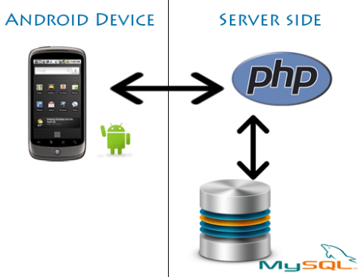

3. Specific Requirements
  - External Interface
    - User Interface
The user should download the app and install on his android based device. After installation ParkMe Icon will be displayed on the device screen. ParkMe splash screen will appear upon opening the application.
Registration
Then the application moves to the login page. For the first time, the user has to register his primary details with the application. This is a one-time registration. The user has to enter his details like username, password, gender, contact number and email-id. All this data will be stored on server. Booking for slots should be done two hours prior to arrival. Once the registration is successfully completed client can use his email id and password to login in future.
Selection of parking location
The client is provided with multiple parking locations within CDU campus from which he can select one.
Availability status of the slots
Based on availability, the empty slots will be displayed along with the total slots. Color coding is used to indicate empty and reserved slots. Green indicates empty slots and Red indicates that currently the slot is reserved.

Slot Reservation
Once the slot is available, the client can proceed further with the reservation process or else he can go back to change the location type or else can terminate the entire process.
The slot reservation is based on time slots. Once a slot is selected a certain time slots of 30 minutes each will appear on the screen. User can select the time slots according to how long he wants to park his/her car.
Payment and Booking confirmation
Once the slot selection is made, the next step is payment. Payment is made through credit/debit card or online banking transactions. The user should enter the card details and upon successful payment, a confirmation page will appear on the screen with the transaction ID and booking number.

4. Feasibility Study
Current system in the CDU campus does not allow a user to book a parking spot in a particular area in advance. To satisfy the increasing demand for the parking areas, we are trying to implement a better and technologically advanced solution. A variety of methodologies have been implemented by similar organizations to provide parking availability information through various other platforms. Most of the parking facilities are based on First come first serve approach. The ParkMe application will enable the user a real-time parking availability tracking and online reservation thereby providing a trouble-free parking solution for users.
Benefits of this APP include:
- Cost effective solution to eliminate parking problems.
- Reduce Pollution and Fuel wastage to a great extent.

